Notebook 4:

Using EJS with Express JS

* Create your new folder set up your folders running ‘npm init’ and ‘npm install express’

Next were going to create a new module called ‘npm install express’

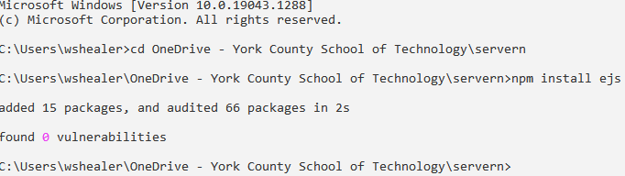

Now inside whatever folder you make this in make a folder named ‘views’ and within that folder make a file named ‘home.ejs’

Next open your app.js file and put your basic requirements

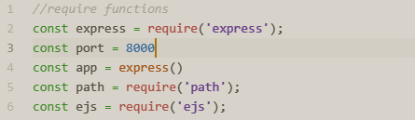

Now we have to tell where your keeping the EJS files

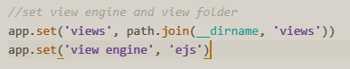

Now we have to create our page with the ‘app.get’ command, use res.render to tell where the file is

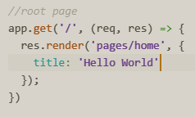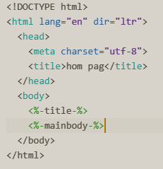

Now open your home.ejs and write

a basic HTML file

Now if everything went correctly it should look like this

